CHB: Academy Logging Script for Yusen

Contents

Summary 1

Scripts Locations 1

Communication Plan 1

How It Works 2

Logic 2

User Guide 2

Known Issues/Notes 3

Technical Documentation 3

SQL Server Object Locations 3

Manual Import of Yusen Report to SQL Server 3

# Summary

In order to mass log the files that come on the weekly Yusen 30-Day Forecast report, the report is imported into IAH’s SQL Server for data formatting and translating. Once translated, data is output to the desktop script input files for the user to run a CFIT desktop script.

# Scripts Locations

1. Mass Logging Version - Logs all MBLs (1 MBL per file) except where the origin is Chittagong
   1. "F:\Scripting\Import\CHB_IMPORT_ACADEMY_QUICKLOG\INDEXED_VERSION\CHB_IMPORT_ACADEMY_MASS_LOG_VERSION_003.eds"
2. Single File Version - Logs Multiple MBLs in 1 file (used for Chittagong Shipments)
   1. "F:\Scripting\Import\CHB_IMPORT_ACADEMY_QUICKLOG\INDEXED_VERSION\CHB_IMPORT_ACADEMY_QUICKLOG_INDEXED_VERSION_CHITTAGONG_MULTI_MB_004.eds"

## Input/Output Files

1. Skipped files, list of MBLs that aren’t logged and the date it tried to log
   1. "F:\Scripting\Import\CHB_IMPORT_ACADEMY_QUICKLOG\INDEXED_VERSION\Output\Skipped_Files.csv"

# Communication Plan

Please submit a ticket through PMA

1. For any changes or updates to the Academy Yusen 30 Day Report, including column name changes, newly added columns, and removed columns.
2. For any enhancements to the script
3. For any issues with the Desktop Scripts, please include screenshots

Weekly Updates

1. **\*Place the report in an F Drive location: F:\FTP\CHB_ACADEMY_YUSEN_REPORT**

# How It Works

Overview of major steps

1. The Yusen 30 day forecast report gets emailed weekly as an Excel file
2. The report gets uploaded to IAH’s SQL Server
3. SQL Server will output the input files for the Desktop Script
4. User runs script in CFIT
5. Origin Ports are managed in Input/ports_origin.csv

## Logic

1. Script logs every applicable file based on Masterbill Number (1 masterbill per file)
2. Excludes shipments from Chittagong (Load port = CGP)

# User Guide

## How to Update Origin Ports

1. Open in Excel "F:\Scripting\Import\CHB_IMPORT_ACADEMY_QUICKLOG\INDEXED_VERSION\Input\ports_origin.csv"
   1. 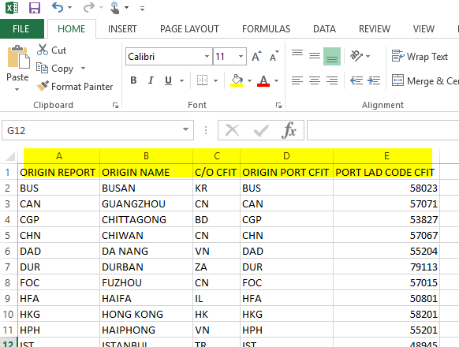
2. Modify the port data (refer to above screenshots)
   1. **ORIGIN REPORT** column is the port code provided by the 30 day Yusen Report
   2. **ORIGIN NAME** column is just for user reference
   3. **C/O CFIT** column is the country of origin required by CFIT
   4. **ORIGIN PORT CFIT** column is the origin port code required for CFIT
   5. **PORT LAD CODE CFIT** column is the 5-digit code required for CFIT

# Known Issues/Notes

1. 3/6/2018 – Migrated to SQL Server from Macro because was taking hours to run due to it being over 18,000 lines long
2. **3/6/2018 – Meeting Notes :** 
   1. Create an output for all of the skipped MBLs for later investigation eta/Thursday
   2. GBO need to write a query to match MBLs against ETMS to avoid the script running through the same files

# Technical Documentation

Reference for IAH-GBO team

## SQL Server Object Locations

1. Database - IMPORT_DATA
2. Table Raw Data - Table where the raw report data is stored
   1. [IMPORT_DATA].[dbo].[CHB_ACADEMY_YUSEN_REPORT_RAW]
3. Table Report Data - Table where data has been translated and formatted
   1. [IMPORT_DATA].[dbo].[CHB_ACADEMY_YUSEN_REPORT_DATA]
4. Table Port Codes - Table where the port code translations for CFIT are stored
   1. [IMPORT_DATA].[dbo].[CHB_ACADEMY_YUSEN_PORT_CODE]
5. Stored Procedure that translates the Raw data into formatted data and merges port code list to table
   1. dbo.SP_CHB_ACADEMY_YUSEN_MERGE
6. Stored Procedure that creates MBL Input for Mass Logging Version of desktop script
   1. dbo.SP_CHB_ACADEMY_YUSEN_MASS_LOGGING_INPUT_MBL
7. Stored Procedure that creates References Input for Mass Logging Version of desktop script
   1. dbo.SP_CHB_ACADEMY_YUSEN_MASS_LOGGING_INPUT_REF
8. Function that returns the CFIT port using the Port from the Yusen Report
   1. dbo.UDF_CHB_ACADEMY_YUSEN_PORT_CODE_CFIT

## Manual Import of Yusen Report to SQL Server

*SSIS Package is TBD, also perform steps if stored procedure is not working.

1. Open report and remove header, usually rows 1-9
   1. 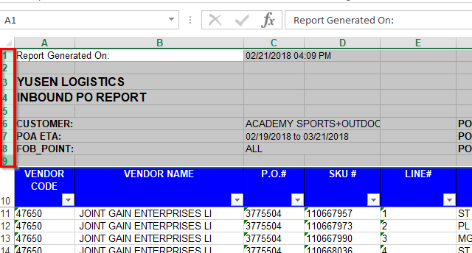
2. Select all and format as text
   1. 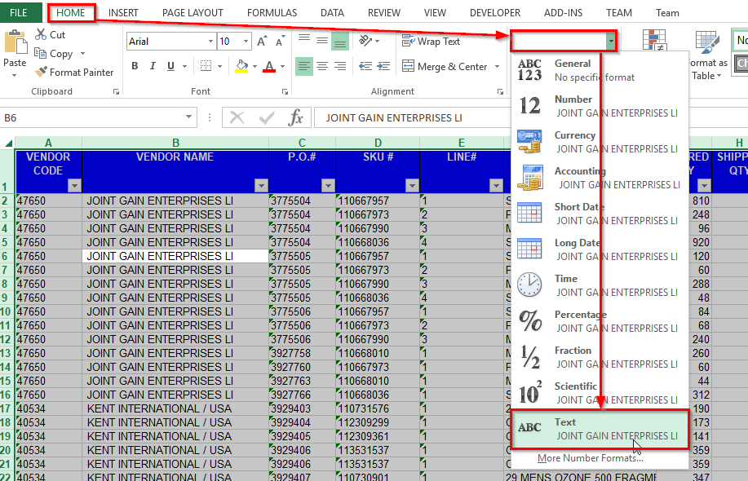
3. Save the file and remember where you saved it
   1. 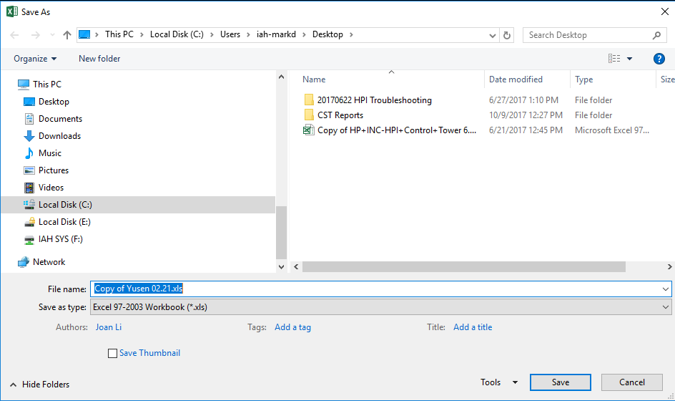
4. Open SQL Server Management Studio and connect to IAH (10.22.10.165,8570)
5. Right click the database “IMPORT_DATA” and select Tasks->Import Data to open the SQL Server Import and Export Wizard
   1. 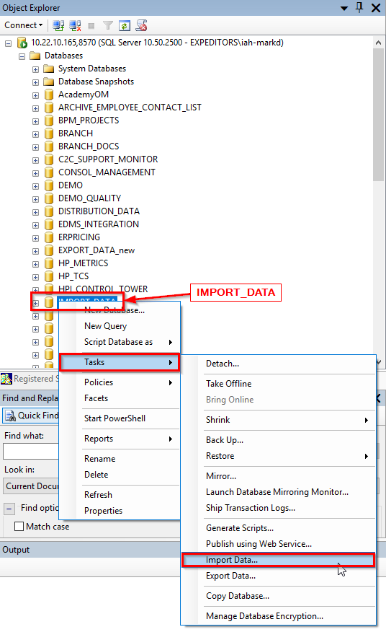
6. For Data Source choose Microsoft Excel
   1. 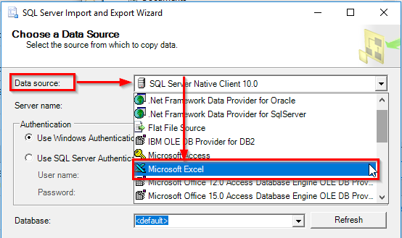
7. Browse for the filepath, select the file, then click next
   1. 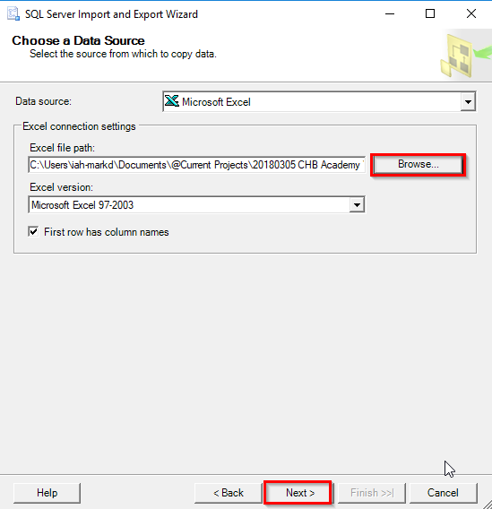
8. Click Next, default settings are ok (screenshots)
   1. 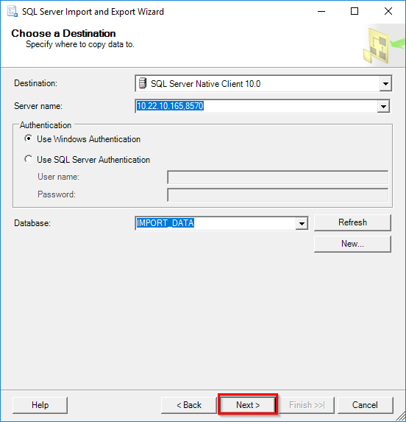
9. Click Next, default settings are ok (screenshots)
   1. 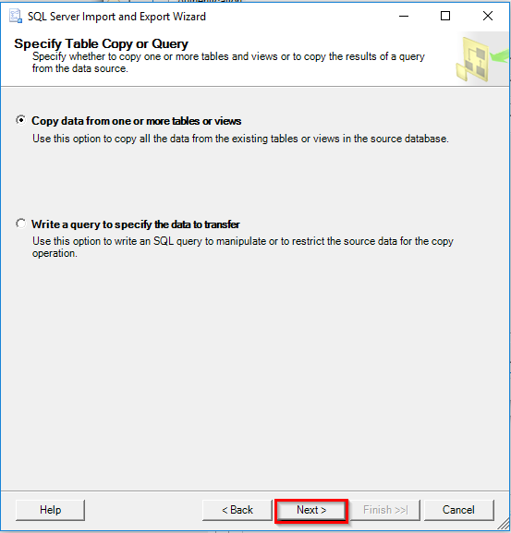
10. Check the first checkbox for under the Source column, and select [dbo].[**CHB_ACADEMY_YUSEN_REPORT_RAW**] under the Destination column. Then click next.
    1. 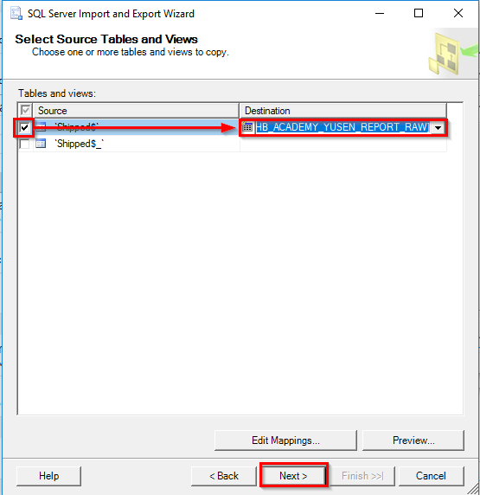
11. Make sure Run Immediately is checked by default, then click Next.
    1. 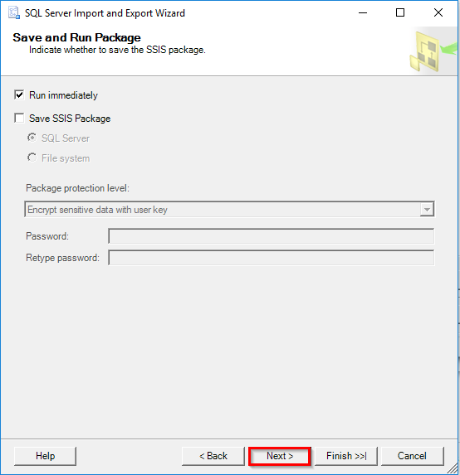
12. Click Finish and the data should import. If it does not, then review the steps, or there is an issue with the column mapping.
    1. 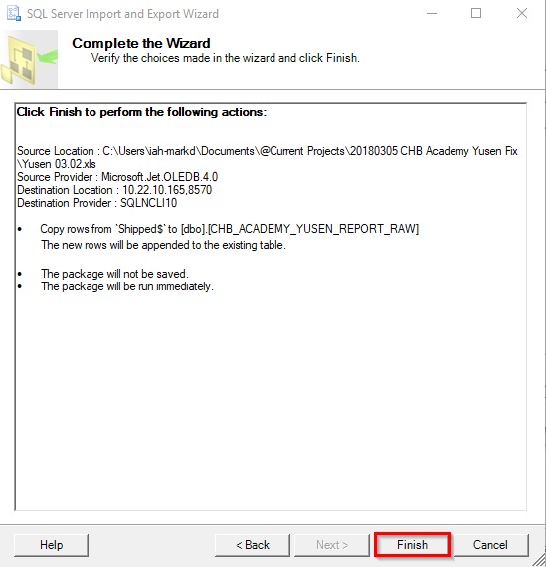
13. This is what it should look like (screenshot). Click close
    1. 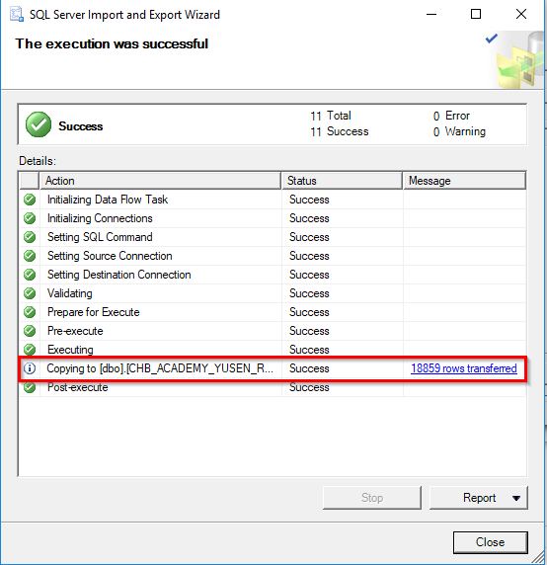
14. Run the following SQL code to execute stored procedures.

USE [IMPORT_DATA]

GO

EXEC dbo.SP_CHB_ACADEMY_YUSEN_MERGE

EXEC dbo.SP_CHB_ACADEMY_YUSEN_MASS_LOGGING_INPUT_MBL

EXEC dbo.SP_CHB_ACADEMY_YUSEN_MASS_LOGGING_INPUT_REF

1. Three separate result sets will come up (screenshot below).
   1. The first one is just the result of the translation
   2. The second one you will need to copy and paste into the input file (also make sure it’s comma delimited): **"F:\Scripting\Import\CHB_IMPORT_ACADEMY_QUICKLOG\INDEXED_VERSION\Input\output_mass.csv"**
   3. The third one you will need to copy and paste into the input file (also make sure it’s comma delimited): **"F:\Scripting\Import\CHB_IMPORT_ACADEMY_QUICKLOG\INDEXED_VERSION\Input\output_references_mass.csv"**
   4. 